**Class Diagram:**

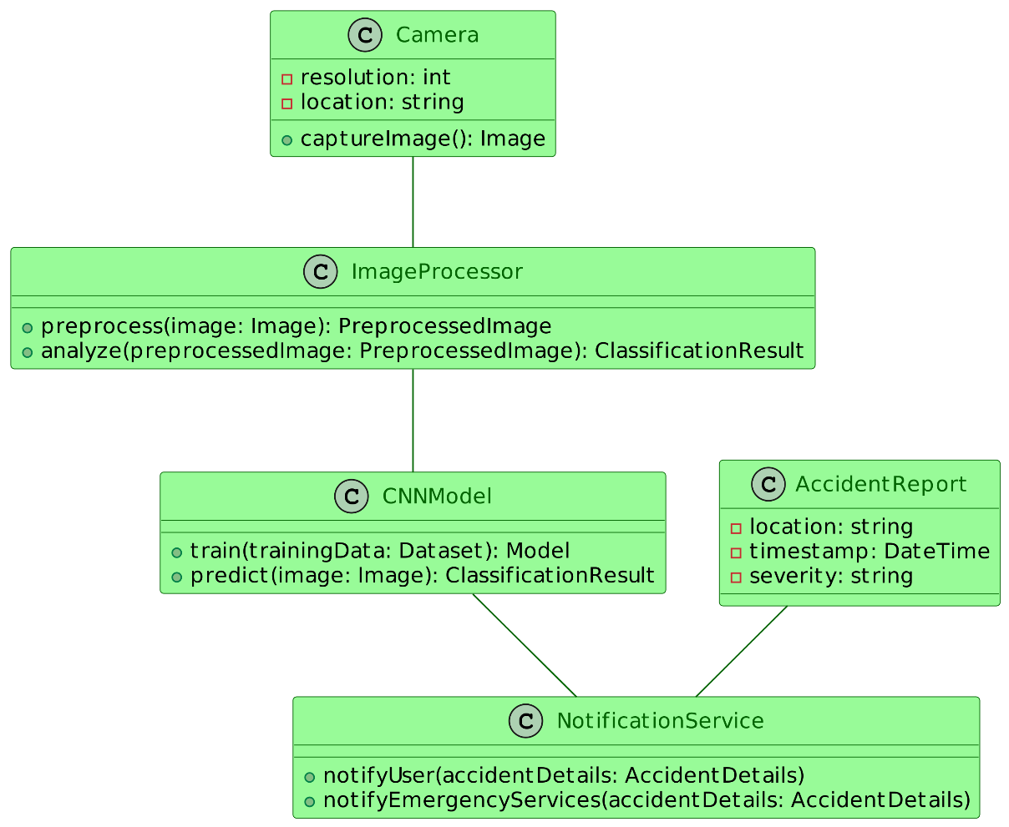

1. **Camera:**
   * The Camera class represents a physical camera device installed on the highway.
   * It captures live video feed from its location.
   * The **captureImage()** method is responsible for capturing an image from the video feed.
2. **ImageProcessor:**
   * The ImageProcessor class processes the captured images to prepare them for analysis.
   * The **preprocess(image)** method takes an image as input and performs preprocessing tasks such as resizing, normalization, and noise reduction.
   * The **analyze(preprocessedImage)** method analyzes the preprocessed image to detect whether an accident has occurred.
3. **CNNModel:**
   * The CNNModel class represents a Convolutional Neural Network (CNN) model.
   * The **train(trainingData)** method is used to train the CNN model using a dataset containing labeled images of accidents and non-accidents.
   * The **predict(image)** method takes an image as input and predicts whether it contains an accident based on the trained model.
4. **NotificationService:**
   * The NotificationService class handles the notification process once an accident is detected.
   * The **notifyUser(accidentDetails)** method notifies the relevant users about the detected accident, providing details such as location, timestamp, and severity.
   * The **notifyEmergencyServices(accidentDetails)** method notifies emergency services (e.g., ambulance, police) about the detected accident for timely assistance.
5. **AccidentReport:**
   * The AccidentReport class represents a report containing details about a detected accident.
   * It typically includes information such as the accident location, timestamp, and severity.
   * This information is used by the NotificationService to notify users and emergency services.

In summary, the Camera captures live video feed, which is processed by the ImageProcessor. The preprocessed images are then analyzed by the CNNModel to detect accidents. Once an accident is detected, the NotificationService notifies users and emergency services, utilizing information from the AccidentReport. This collaborative effort of the classes ensures timely detection and notification of accidents, potentially saving lives on the highway.